1. Main Screen - Welcome

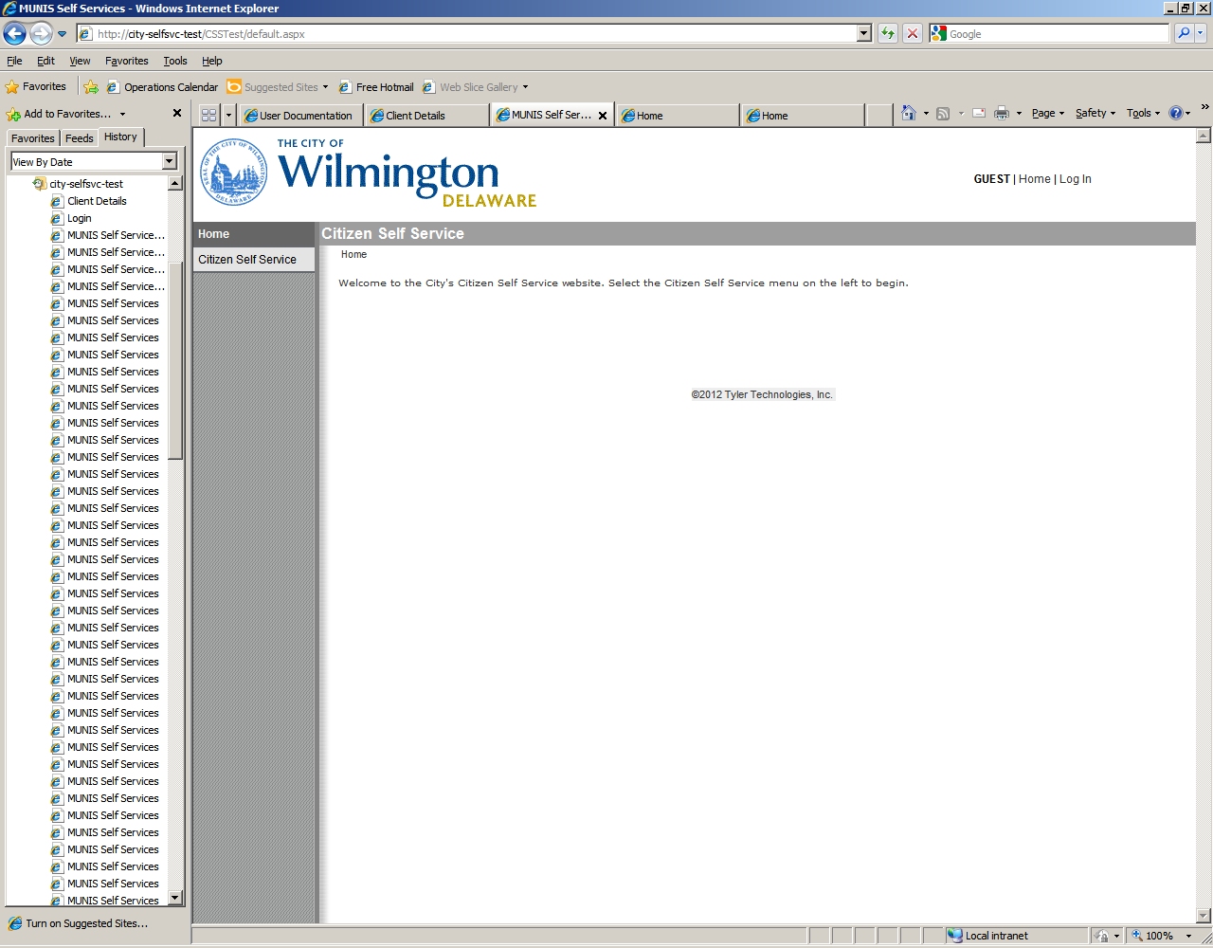

1. Module Screen – Access to the City’s Billed Services by Category.

Click on a Menu item to the left.

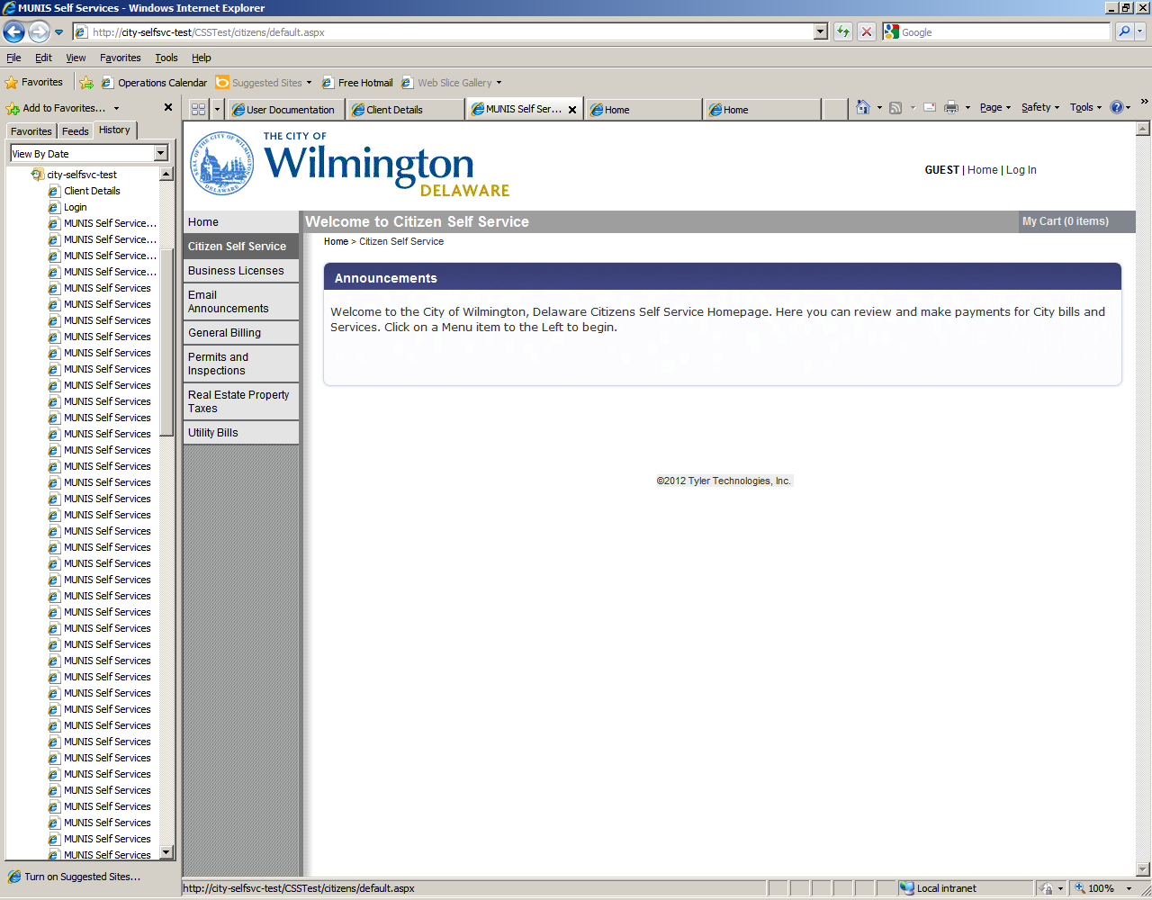

1. Business License – Use this module to search for:

•Business License Bills

•License and Inspection Annual Bills: Elevators, Public Assembly, Signs

•Fire Annual Permits Bills

Please enter as much information as you may have to narrow your search. You can use the * to perform a wild card search, by entering the * before and after some of the information you are searching for.

* Address (Ex. Location Number: 800 Street Name: N FRENCH ST*)
* Owner Name (Ex. Name: *BRUTON*)
* Account Id (Ex. Account ID: 01234).

If you do not see the information you are expecting try to refine your search criteria. If you still do not see the information, or if you are having trouble with this site, please click on the Contact Us menu item to the Left and use the information provided to contact us.

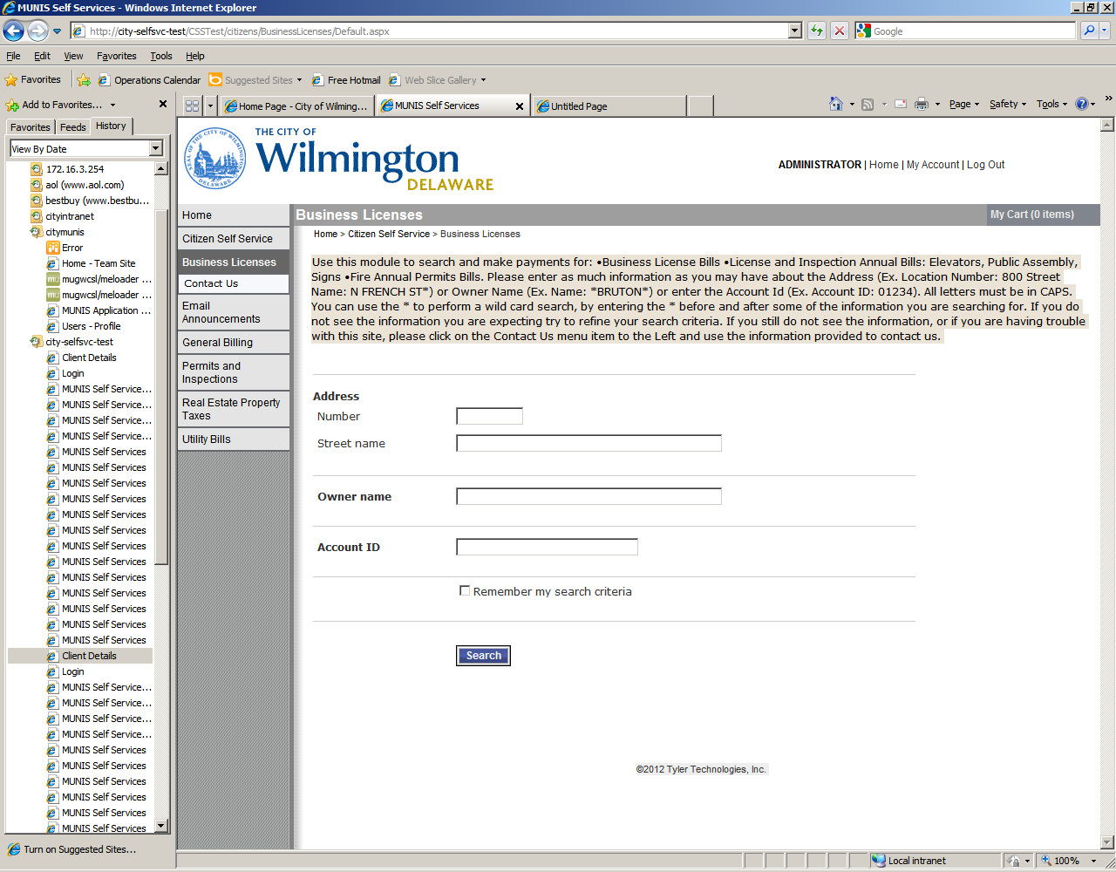

Account Id Search - All bills for the selected account will appear. Click View Bills. Those items with the option to Add to Cart are unpaid.

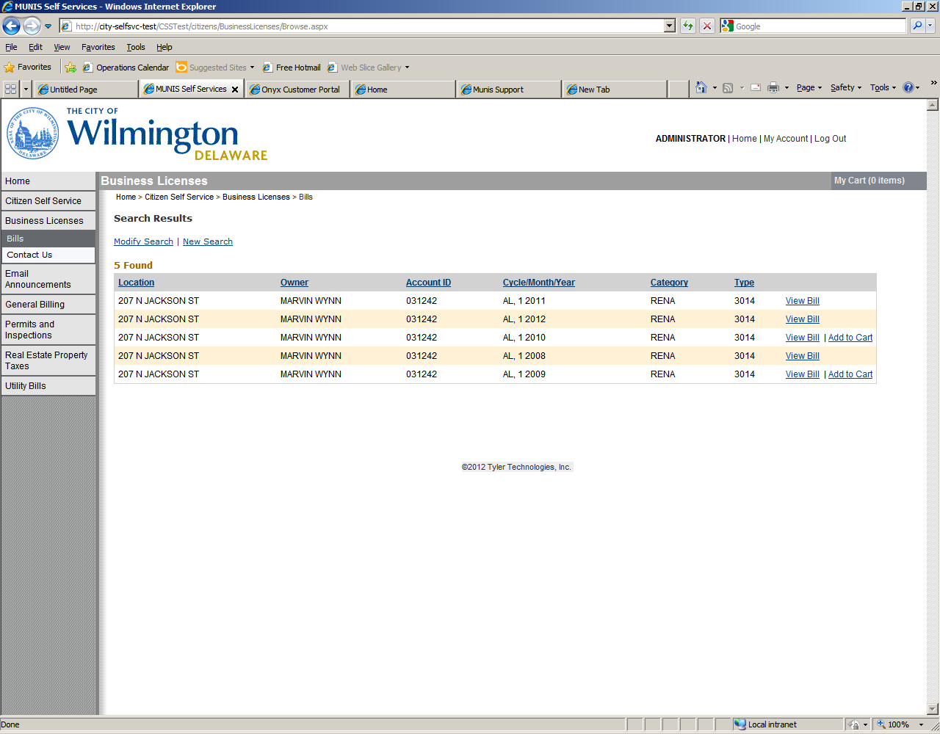

View Bill Screen – displays detail information about the bill.

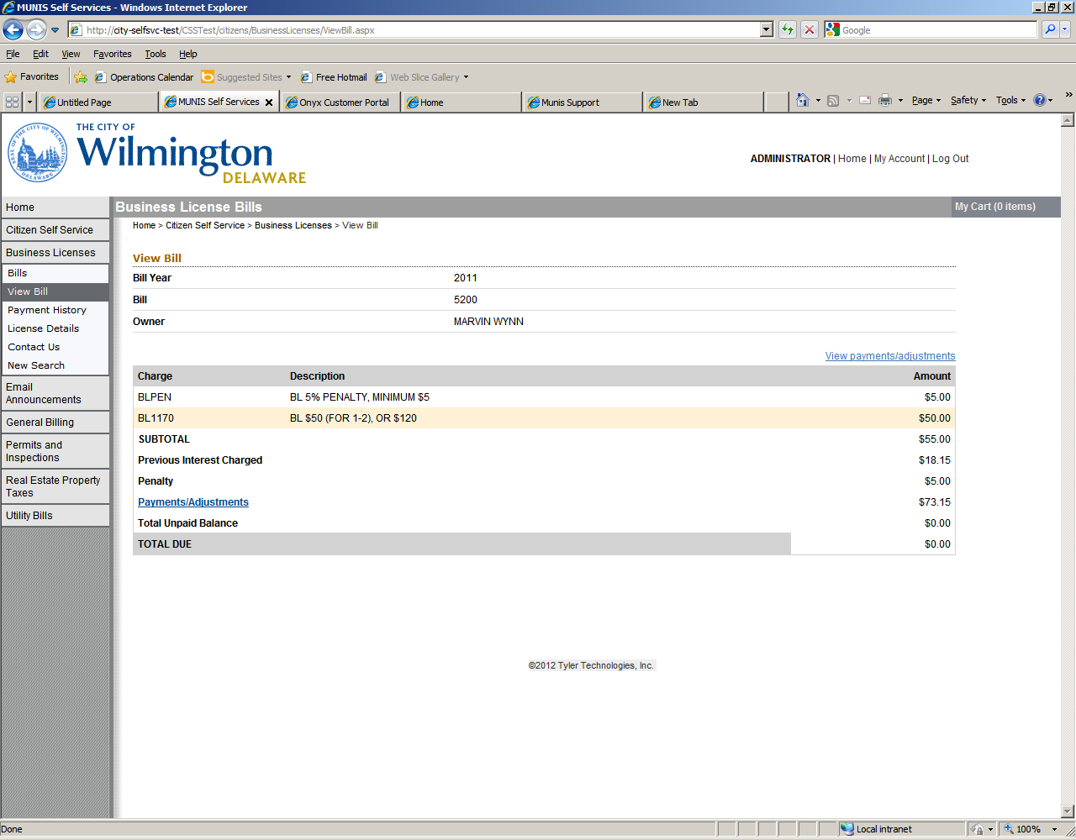

1. General Billing – Use this module to search for General Billing Items:

•General Billing License and Inspection for Property Maintenance Bills

•L&I Instant Ticketing for Instant Ticket Bills

•General Billing Public Works for Roadway Cut Permits

•General Billing Economic Development Invoices

Please enter as much information as you may have to narrow your search. You can use the * to perform a wild card search, by entering the * before and after some of the information you are searching for.

* Owner Name (Ex. Name: *BRUTON*)
* Customer Id Number (Ex. Account ID: 25478)
* Address (Ex. Location Number: 800 Street Name: N FRENCH ST*)

If you do not see the information you are expecting try to refine your search criteria. If you still do not see the information, or if you are having trouble with this site, please click on the Contact Us menu item to the Left and use the information provided to contact us.

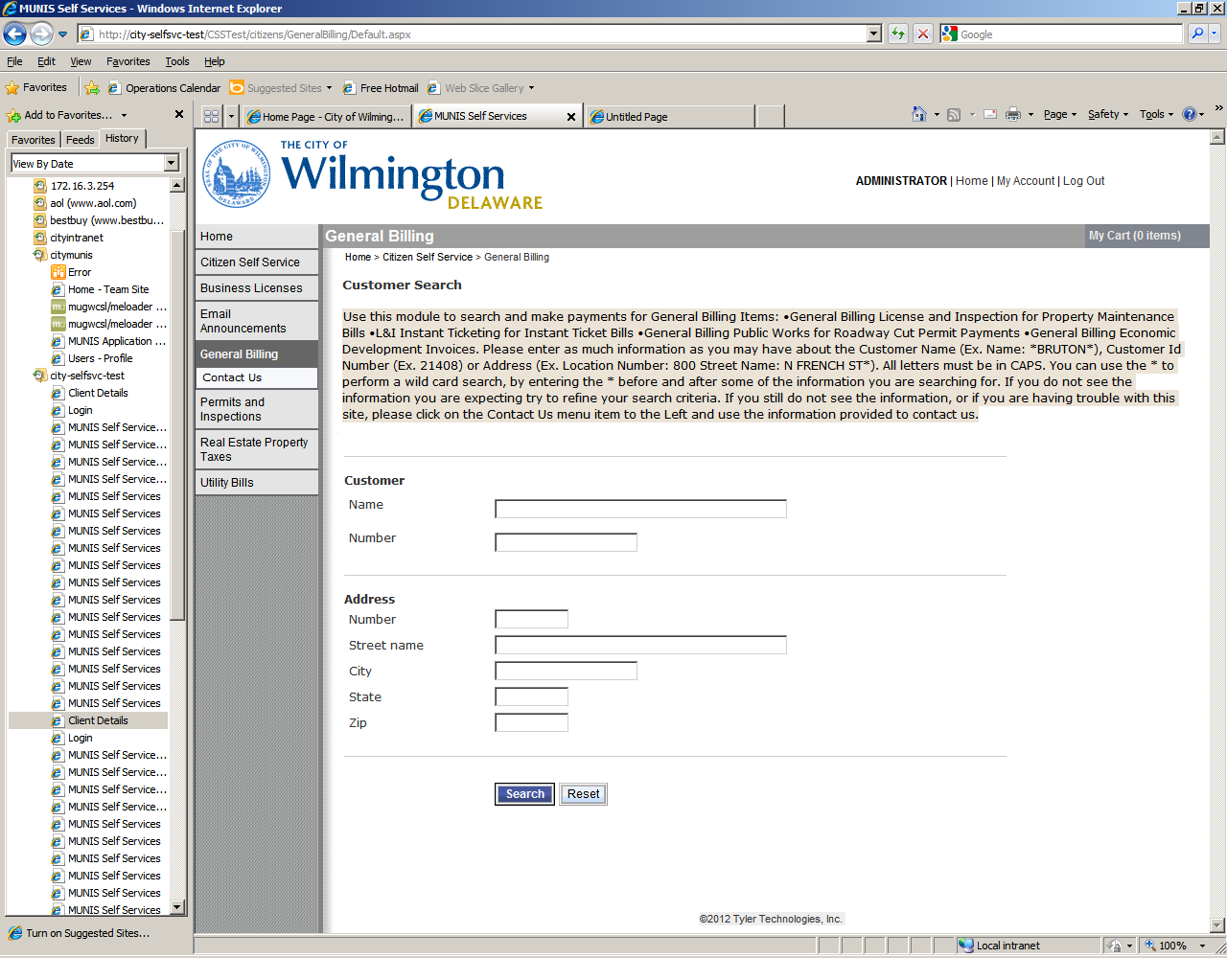

All matches for the search criteria will appear. Find the correct name you are searching for then Click on Manage Bills.

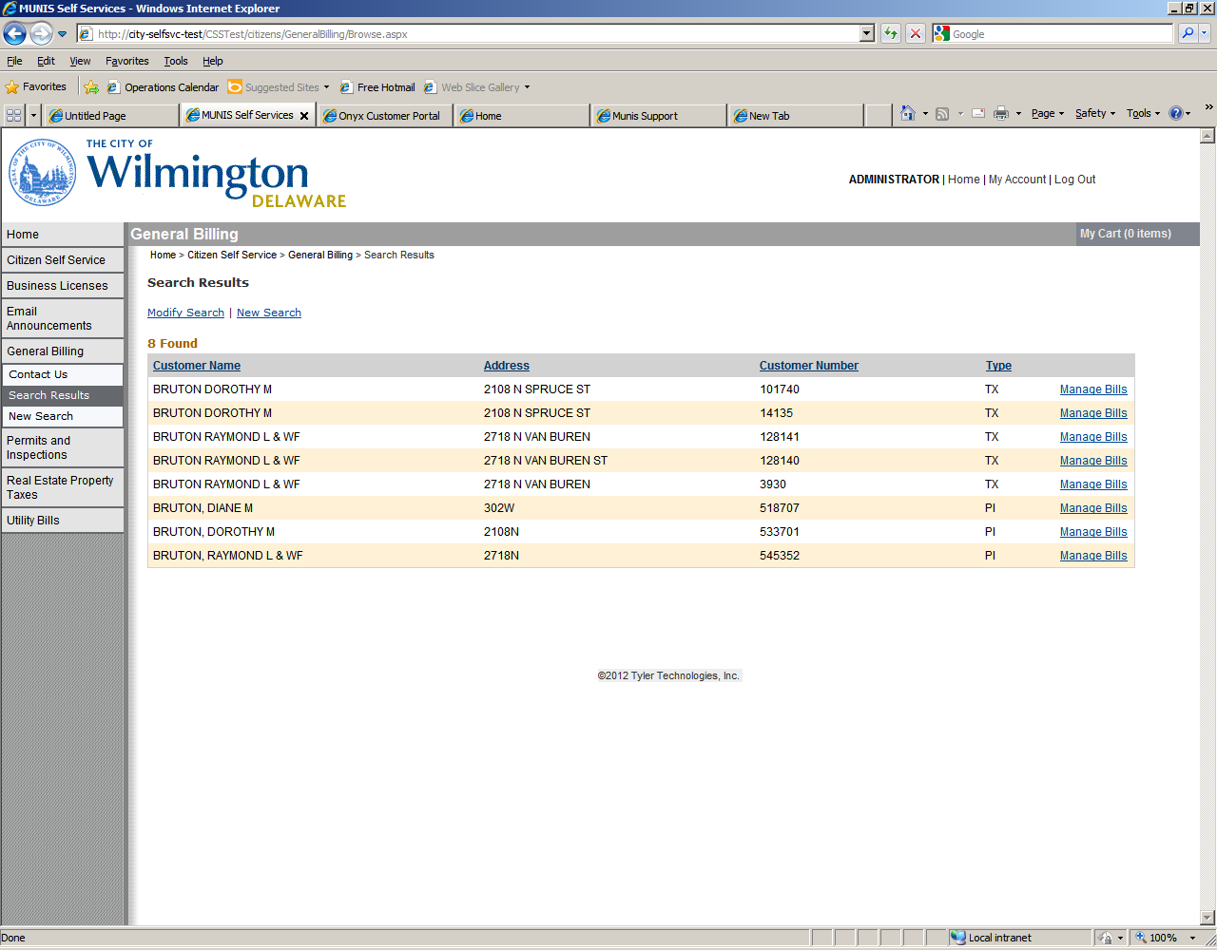

1. Permits and Inspection: Use this module to for Permits for the following Depts

•License and Inspection Permits

or

•Fire Permits.

Please enter as much information as you may have for any of the following fields to narrow your search. You can use the * to perform a wild card search, by entering the * before and after some of the information you are searching for. If you do not see the information you are expecting try to refine your search criteria. If you still do not see the information, or if you are having trouble with this site, please click on the Contact Us menu item to the Left and use the information provided to contact us.

* Permit Location (Ex. Location Number: 800 Street Name: N FRENCH ST*)
* Owner Name (Ex. *BRUTON*)
* Contractor ID# (Ex. 2408)
* Parcel ID# (Ex. 2602320157)
* Application Reference ID# (Ex. 100020204).
* Select the appropriate Permit Status or leave blank.

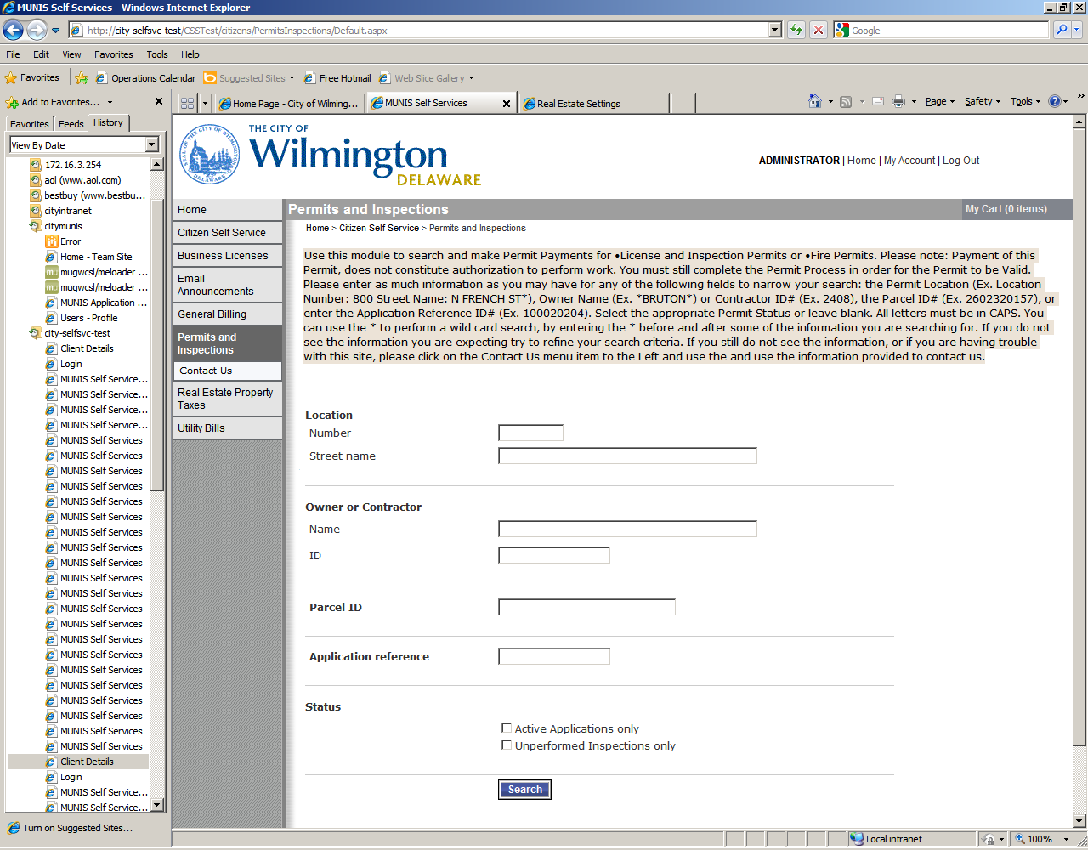

Application and Inspection Information Screen – click on View Details for more information.

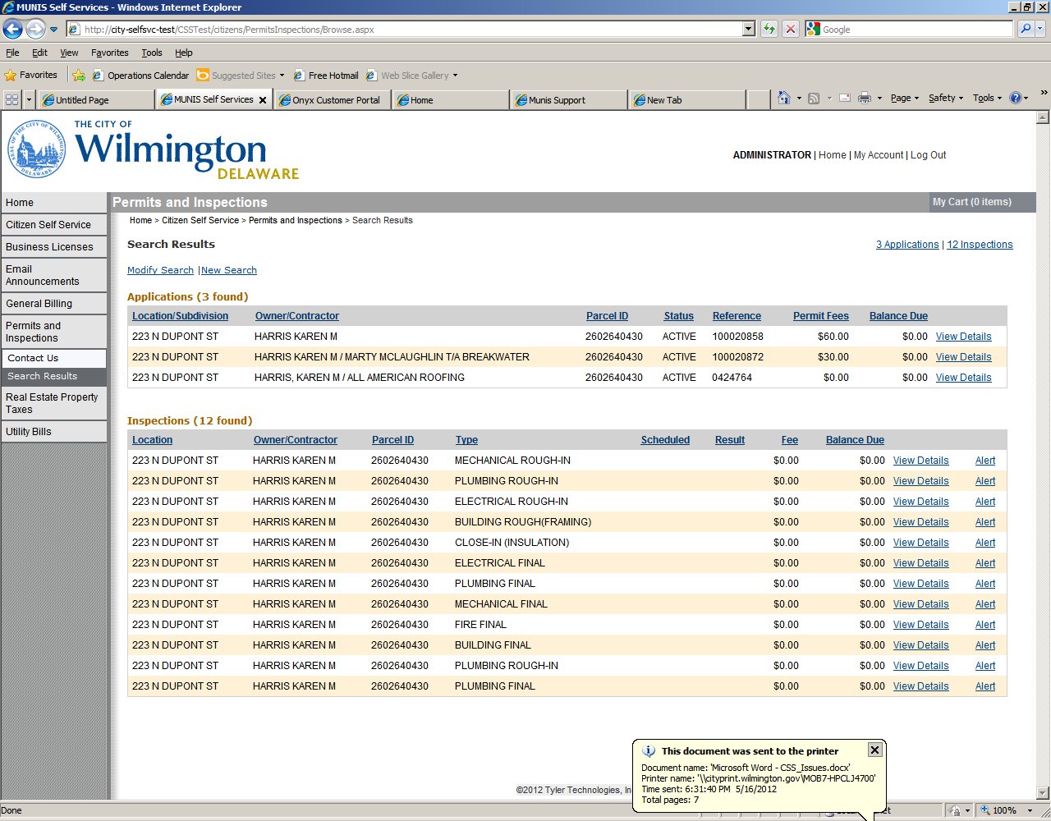

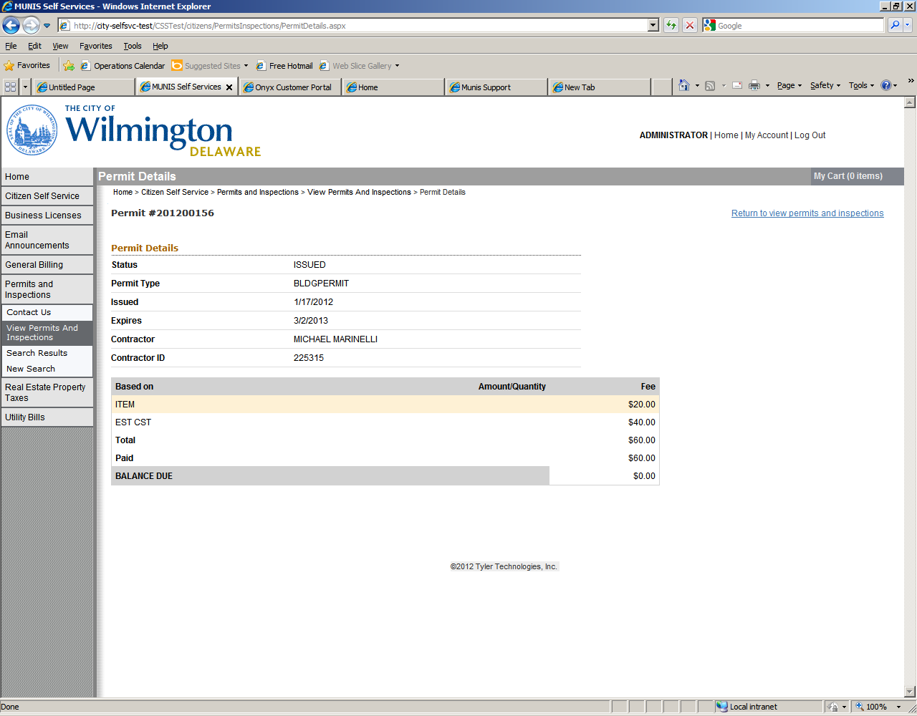

1. Real Estate Property Taxes: Use this module to search for your City’s Real Estate Annual Property Tax Bill.

Please enter as much information as you may have to narrow your search. You must also enter the Tax Year (Ex. Tax Year: 2010). You can use the * to perform a wild card search, by entering the * before and after some of the information you are searching for.

* Ex. Location Number: 800 Street Name: N FRENCH ST*
* Owner Name (Ex. Name: *BRUTON*)
* Parcel Id (Ex. Parcel ID: 2600001234)

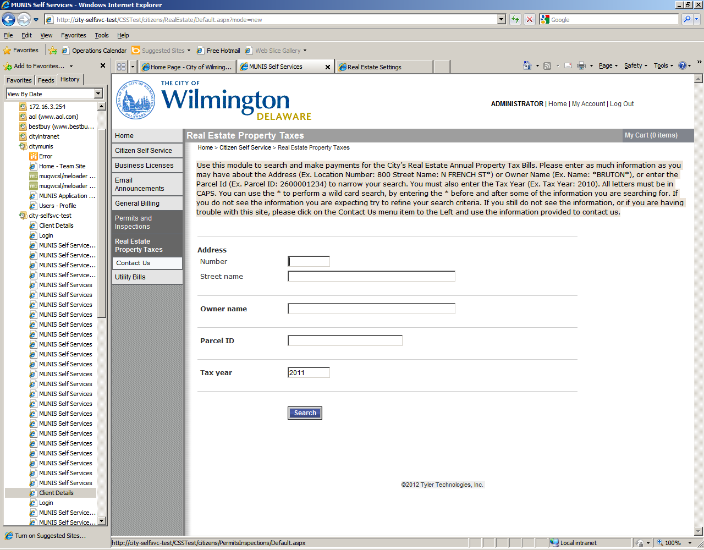

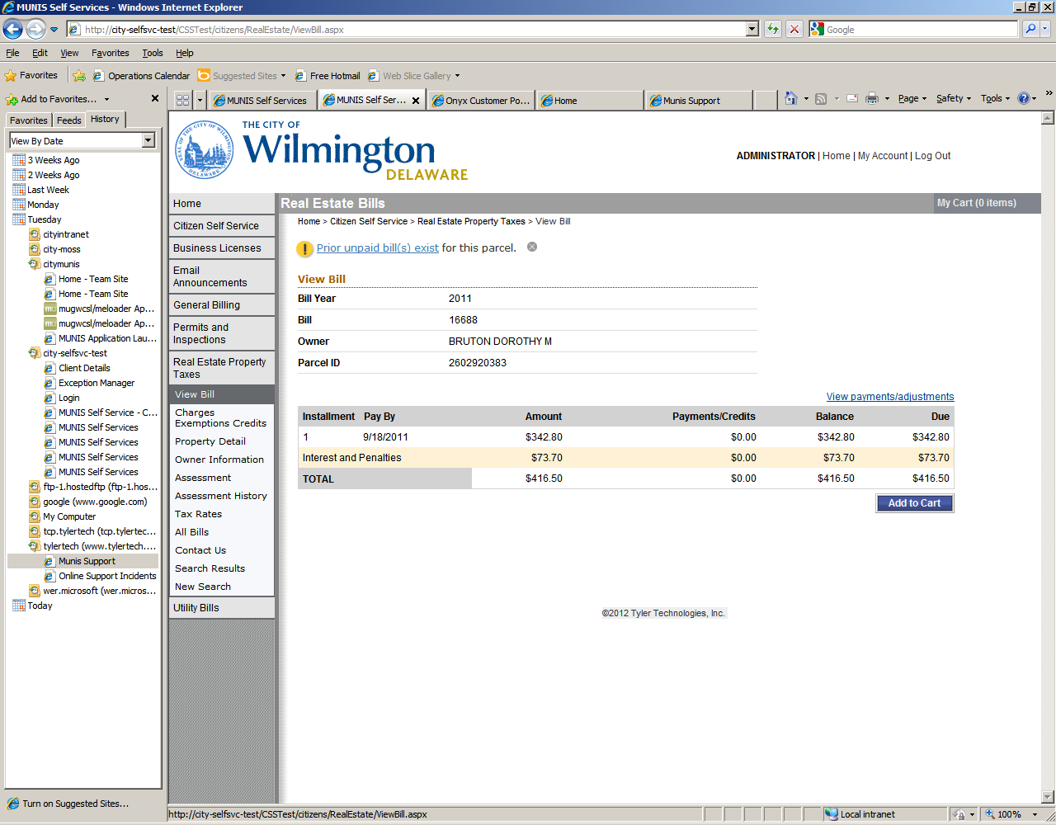

Charges, Exemptions/Credits – displays exemption and bill detail information pertaining to this bill.

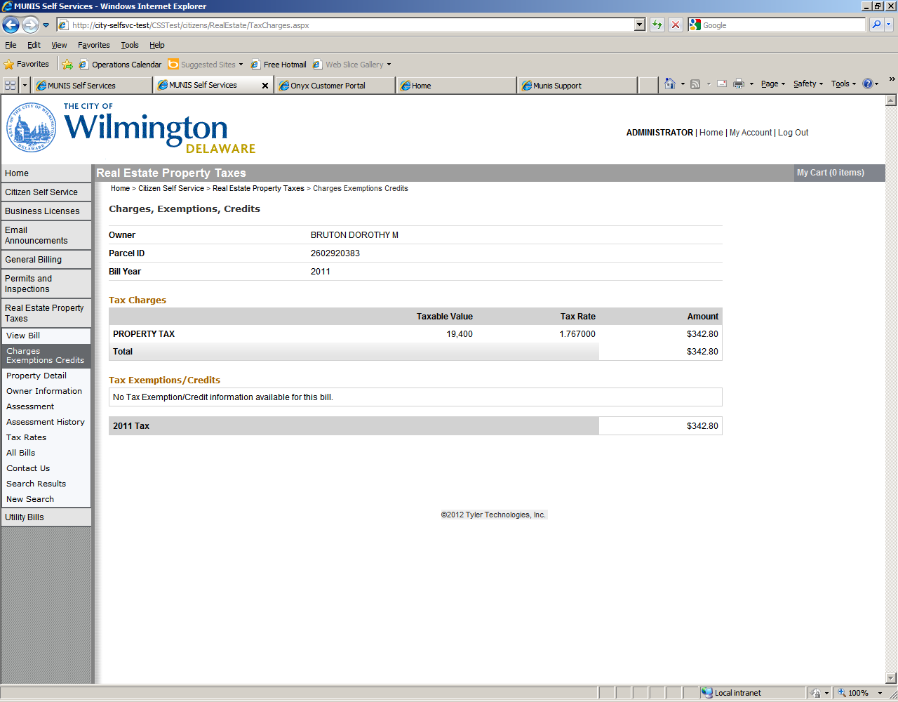

Property Detail Screen

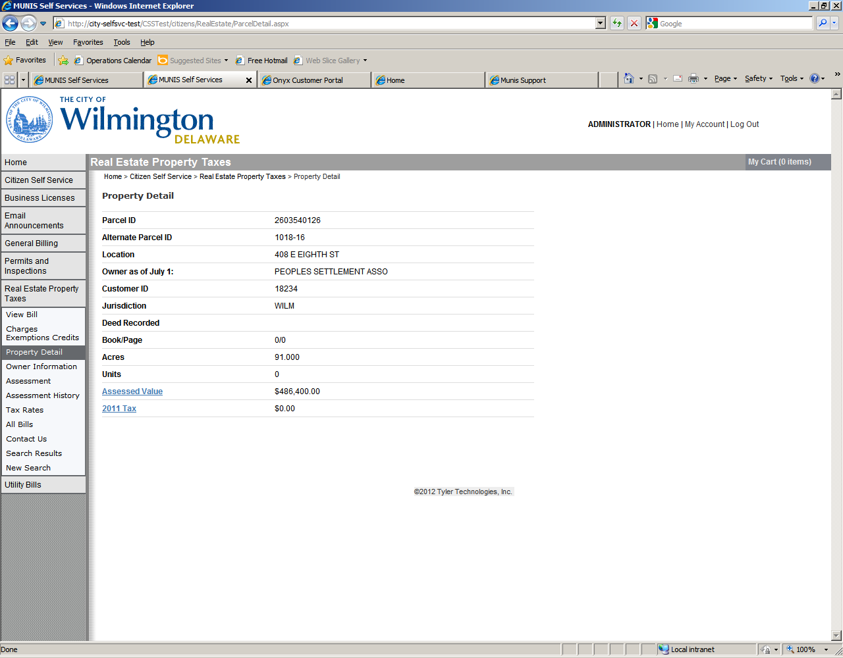

Owner Information Screen

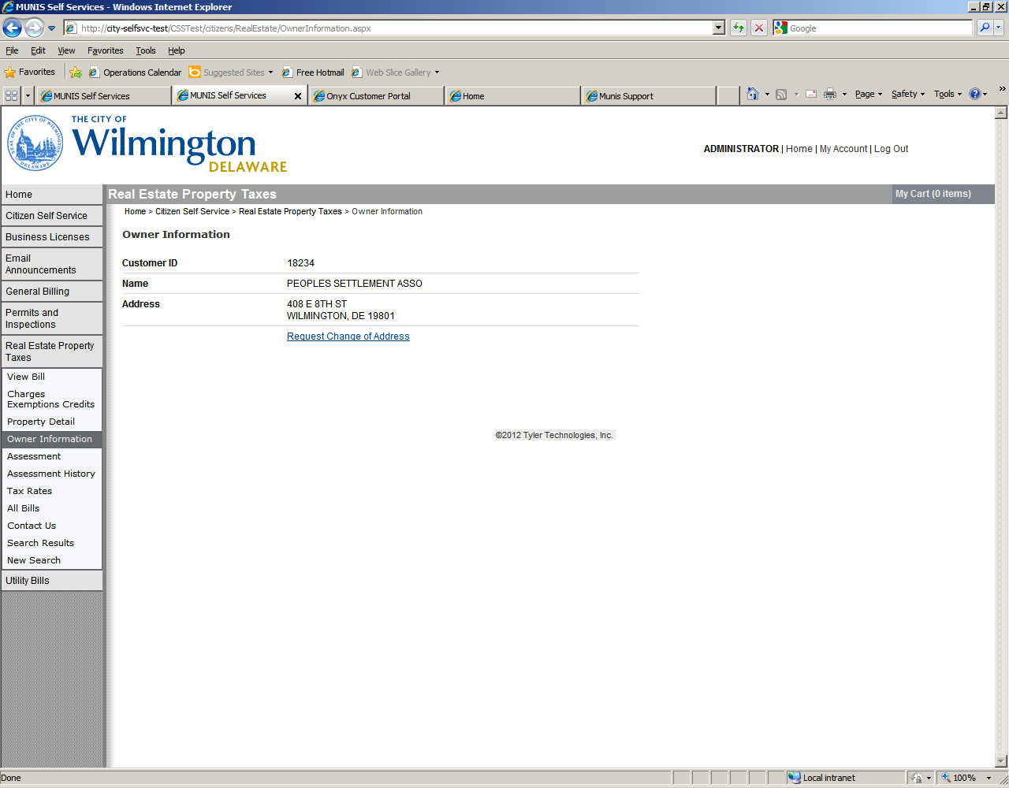

Tax Assessment Screen

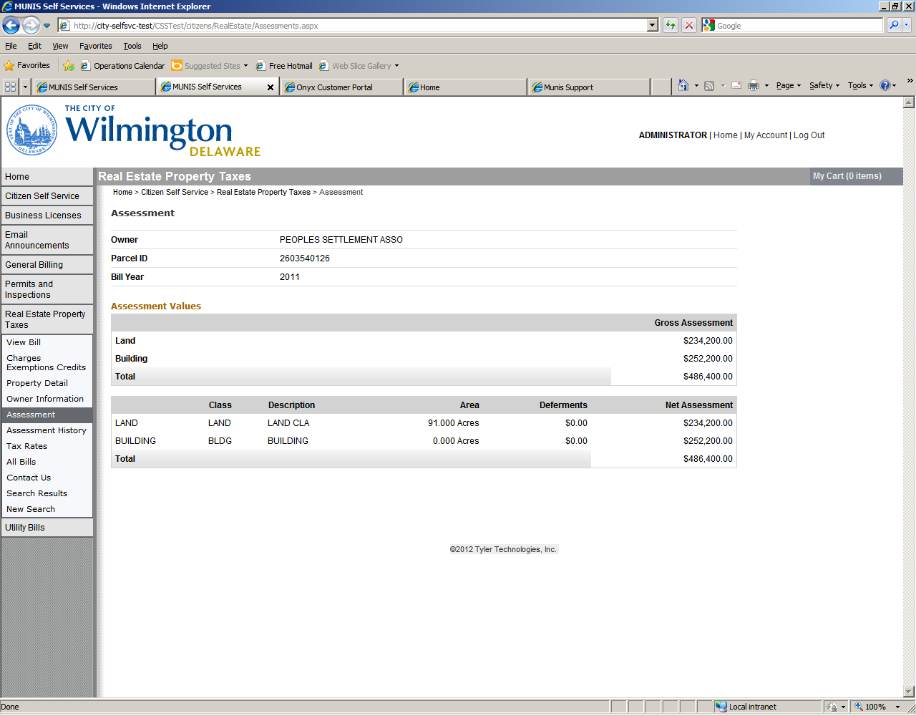

Assessment History

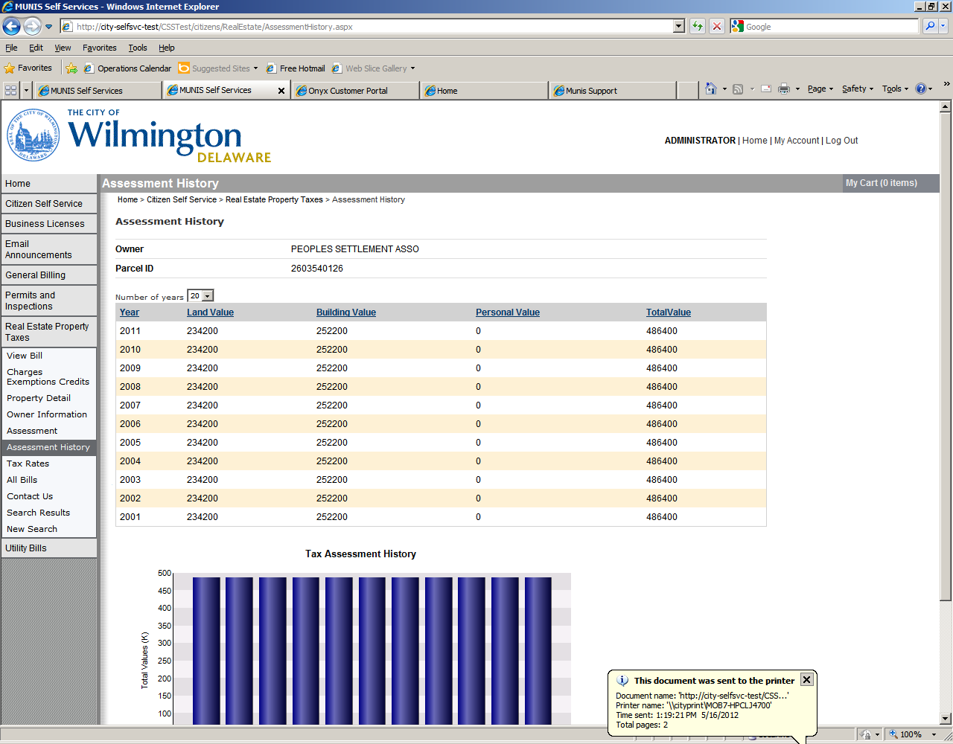

Tax Rate for a specific bill and year

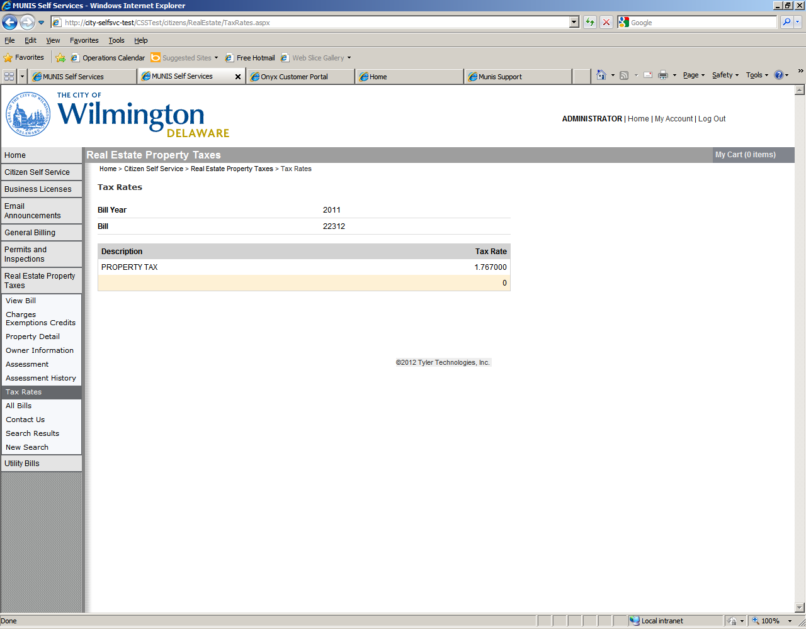

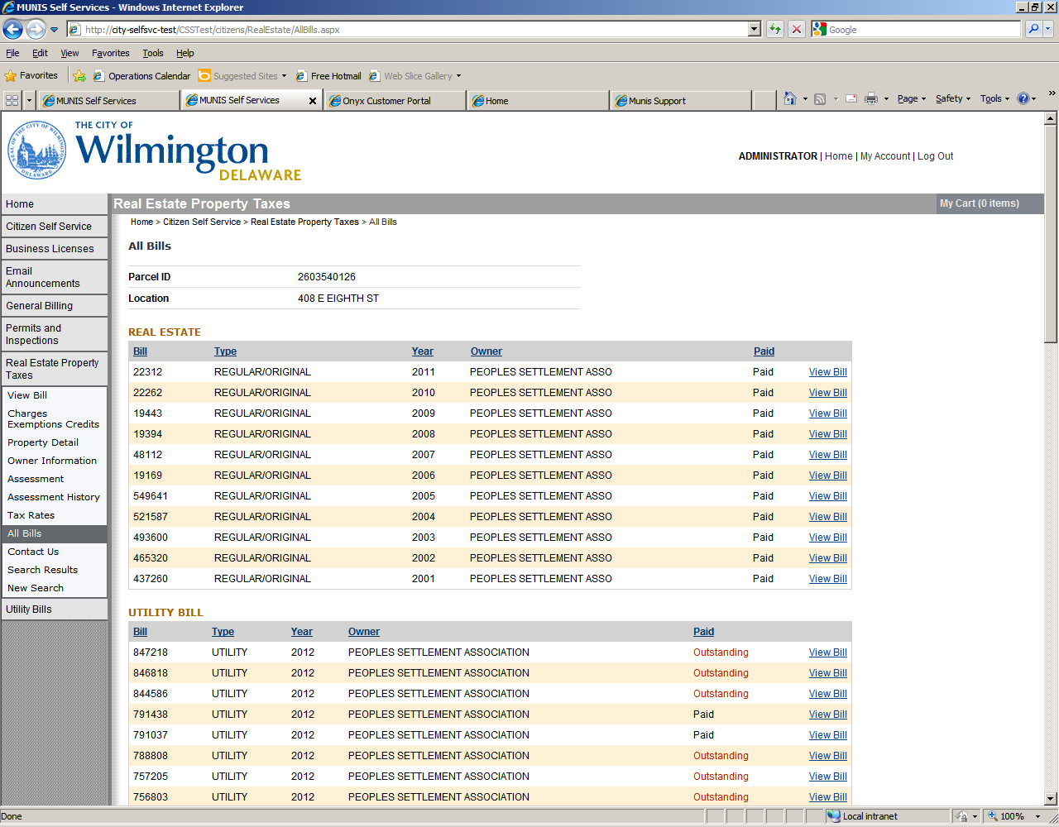

1. **Utility Billing:** Use this module to search for your City’s Quarterly Water, Sewer or Storm Water Bill.

Please enter as much information as you may have to narrow your search. You can use the * to perform a wild card search, by entering the * before and after some of the information you are searching for.

* Account Number (Ex. Account Number: 01234)
* Address (Ex. Location Number: 800 Street Name: N FRENCH ST*)
* Owner Name (Ex. Name: *BRUTON*)
* Parcel Id (Ex. Parcel ID: 2600001234)
* Customer Id Number (Ex. Account ID: 25478)

If you do not see the information you are expecting try to refine your search criteria. If you still do not see the information, or if you are having trouble with this site, please click on the Contact Us menu item to the Left and use the information provided to contact us.

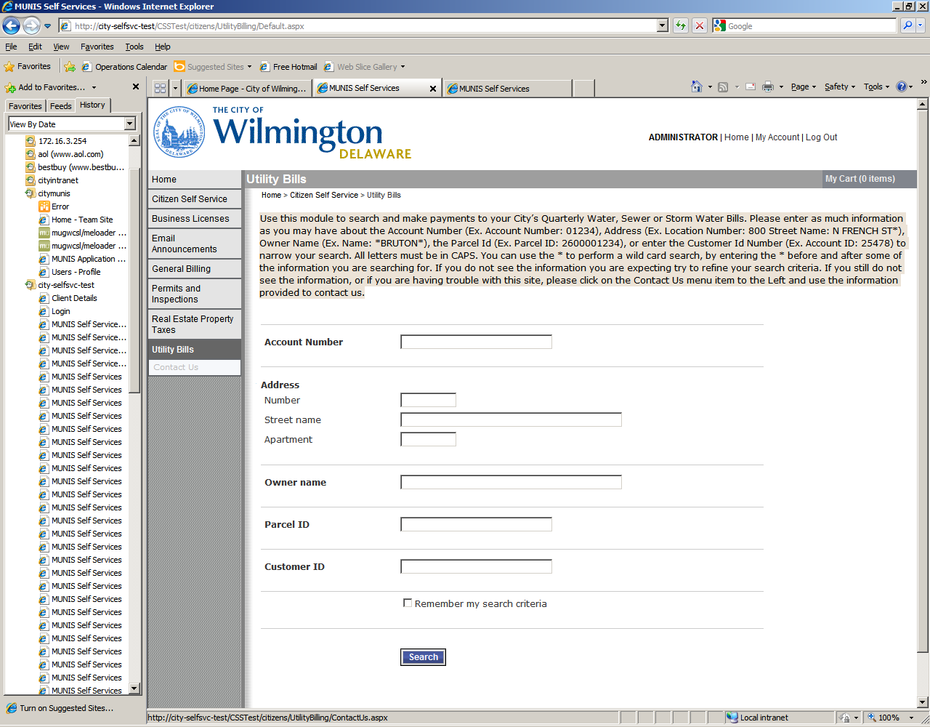

Click Manage Bills

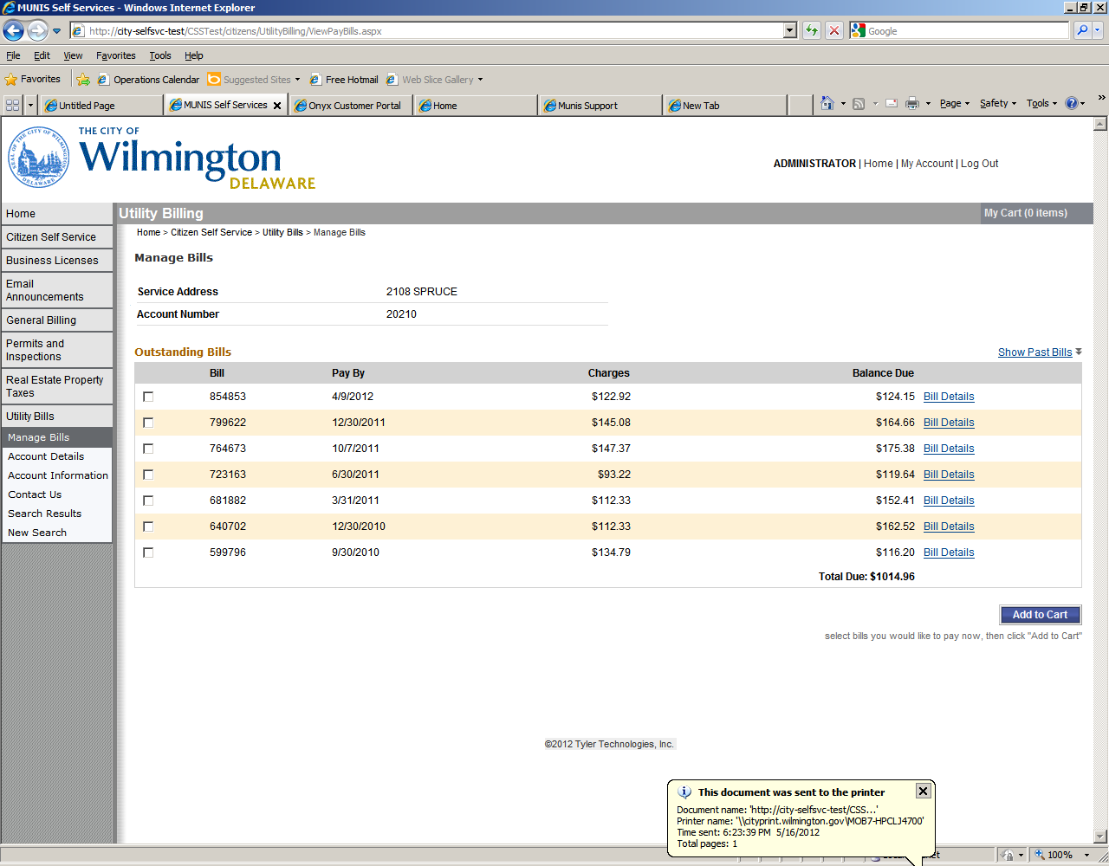

Account Details

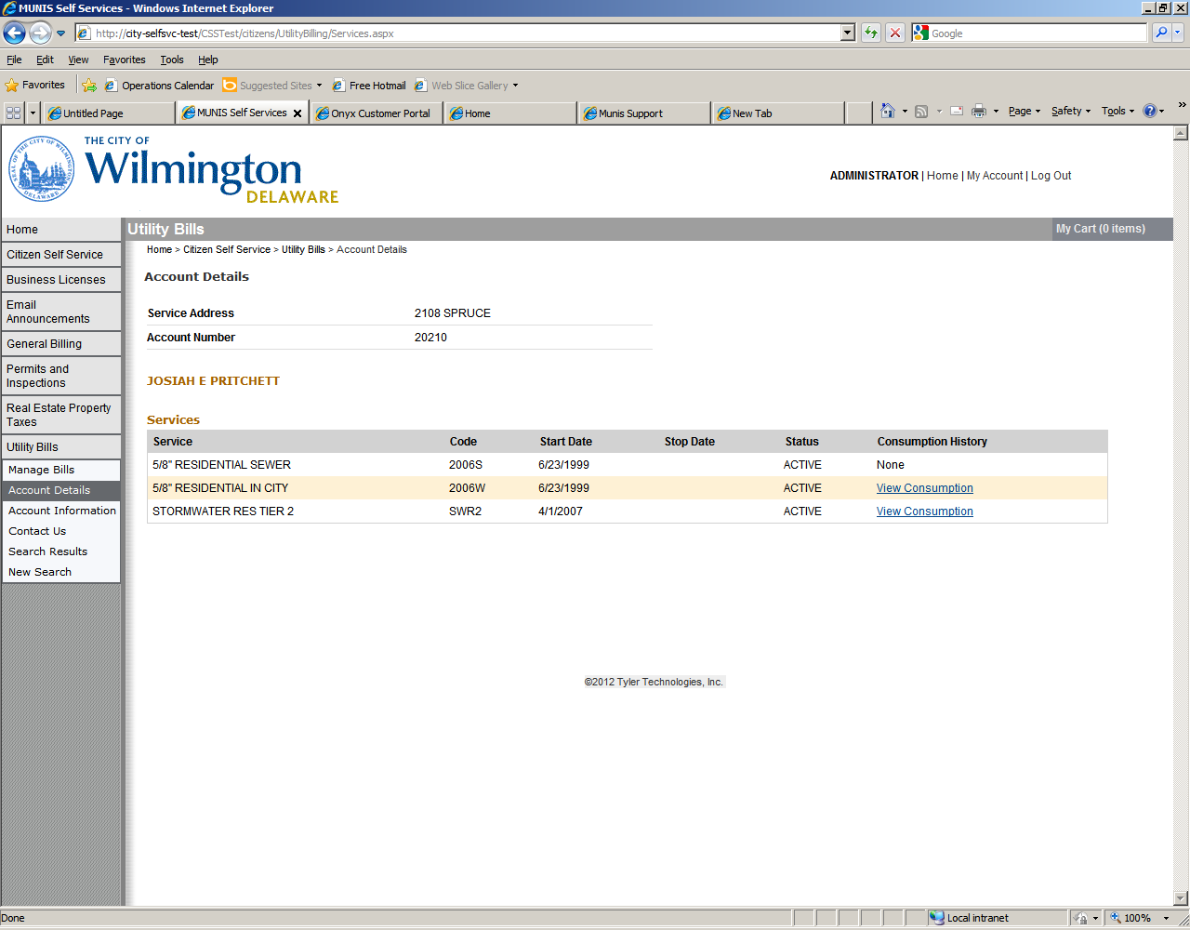

Account Information Screen

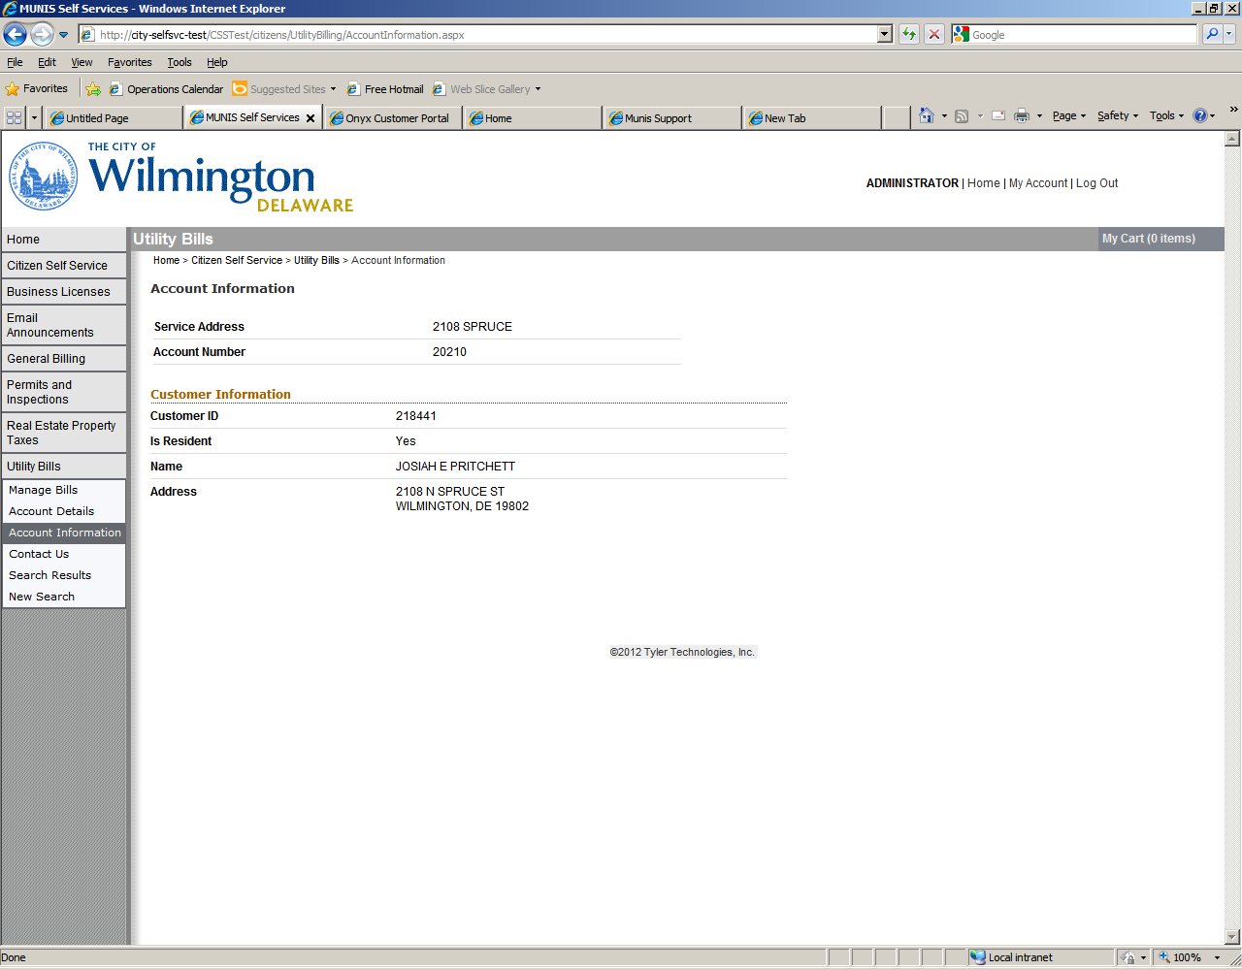

Search Results – modify or start a new search

